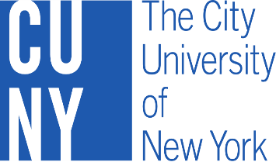
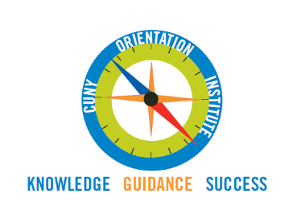

1st Annual CUNY Orientation Institute
Friday, April 7th, 2017
The City College of New York
Faculty Dining Room

Time | Topic | Presenter/Facilitator
9:00 a.m. – 9:30 a.m. | Sign In & Breakfast | Orientation Council
9:30 a.m. – 9:45 a.m. | Welcome Remarks from  The City College of New York | Dr. Juana Reina, Vice President of Student Affairs  Dr. Vincent Boudreau, Interim President
9:45 a.m.-10:00 a.m. | Opening Remarks | Dr. Christopher Rosa  Vice Chancellor of Student Affairs
10:00 a.m. – 11:00 a.m. | Opening Keynote Speaker | Dr. Lynette Cook-Francis  Vice President of Student Affairs  John Jay College of Criminal Justice
11:00 a.m. – 12:00 p.m. | Panel Discussion*  CUNY Orientation; Current Issues and Trends | Manny Lopez  Associate Dean for Student Development  Bronx Community College
12:00 p.m. – 1:00 p.m. | Concurrent Guided Discussion Sessions: Orientation Programming: Current and Future Best Practices | Graduate Students – Jazmin Letamendi, Ph.D  Transfer Students – Christina Waszak  1st Year Students – Dorie Clay  Community College Students – Mary O’Shea. & Joseph Ginese.
1:00 p.m.– 2:00 p.m. | LUNCH
2:00 p.m. - 3:00 p.m. | Social Pedagogies for Online Orientation | Dr. Jennifer Sparrow & Ms. Heidi Baez  School of Professional Studies
3:00 p.m.– 4:00 p.m. | Closing Keynote Speaker | Dr. Felicia McGinty  Vice Chancellor for Student Affairs  Rutgers University
4:00 p.m. – 4:15 p.m. | Breakout Sessions Report | Orientation Council
4:15 p.m. – 4:30 p.m. | Closing Remarks | Dr. Vita Rabinowitz  Executive Vice Chancellor of Academic Affairs

*Panelists:
Dr. Michael Hutmaker, Dean for Student Affairs, Borough of Manhattan Community College
Mr. José Magdaleno, Vice President of Student Affairs, Lehman College
Mr. Matthew Schoengood, Vice President for Student Affairs. CUNY Graduate Center
Dr. Jennifer Sparrow, Assistant Dean for Academic Affairs, CUNY School of Professional Studies

