DATE: SPRING 2018

TO: All Faculty Members

FROM: Pamela Brown, Associate Provost

SUBJECT: eClass Folders

Continuing in SPRING 2018, the college will utilize Excel© eClass Folders for recording student attendance, grades and other information previously recorded on the paper folders. This practice eliminates both the expense and the space needed by departments to store paper folders for many years, and will allow faculty to download rosters from MyInfo directly into eClass folders, as well as perform calculations to compute grades, saving time and minimizing errors.

1. Separate eClass Folders should be used for each section. Templates for class folders will be emailed to all instructors and are also available on the Faculty Commons website: http://facultycommons.citytech.cuny.edu/cuny-first/ Blank paper copies will also be available at the Evening Office window, NG-07.

2. Your semester schedule and class rosters are available in MyInfo. Directions for accessing your semester schedule and class rosters can be found at the end of this memo.

3. Please enter the following into the eClass Folder: Instructor Name; Course code (ie ENG 1101); Section number; Semester (ie SPRING 2018); Meeting times, days and rooms. This information is found in MyInfo, “My Instructor Schedule.” Please notify the department chair if you believe there are any errors.

4. A record of attendance must be maintained for each class meeting using the following notation and initialed: Present (/) Absent (A) Late (L)

5. All student grades that will be factored into the final grade must be recorded in each eClass Folder (see figure, which follows). The designated area on the lower left-hand corner of each class folder is to be used to indicate the nature and weight of each grade recorded. Note: Specific columns are provided to record mid-semester evaluation, final examination and final course grades. To enter this information, Click on the cell where you want the data to go. Click on the double-down arrow to expand your view
of the cell and enter the information.
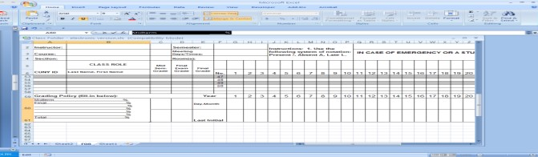
Double-down arrow

6. At the conclusion of the semester, after entering the final grades into the CUNYfirst final grade rosters, instructors must submit the completed eClass folder to the department. The Excel file or a scanned file (11”x17”) are acceptable. Instructors should sign each eClass folder. Electronic signatures are acceptable. You must submit your eClass folder to your departmental college office assistant via your City Tech email account. Personal email accounts should not be used, to assure that it is the instructor making the submission. Please fill in all of the information requested on the eClass folder. The office will not accept your folder unless this information has been provided. This procedure will help to resolve questions that students raise regarding their course grades, especially when they appeal. Use the following convention to name your eClass folder before sending:
i. Course Number ii. Section Number iii. Instructor Name iv. Semester

EXAMPLE: Prof. Jane Doe taught CUNYfirst Basics, CFB 1100, on Thursday evenings, section E584 in Spring 2018. The eClass folder would be named: CFB1100 E584 Doe Spring 2018. If there are two faculty members with the same last name then first initials or first names should be added as well.

Any questions/concerns/suggestions should be directed to your department chair. Thank you for your cooperation in this very important matter.
**

FOR ALL FACULTY:
1. Directions to view your schedule and copy your class roster in MyInfo to the eClass
Folder (note data is not live but updated each evening):

To view your schedule:
1. Go to: https://myinfo.cuny.edu Log in using your CUNY portal user name and password, NOT your CUNYfirst user name and password. If you haven’t yet claimed your CUNY portal ID, go to www.cuny.edu, and follow the links for Log-In > CUNY Portal > Register for a new account > Faculty. Then just follow the simple instructions. The Help Desk (718.260.5610, helpdesk@citytech.cuny.edu) can assist you with any questions or difficulties with MyInfo.

To view your class roster(s) & copy student names and EMPL IDs into eClass Folders:
2. Select My Instructor Schedule
3. Select the correct Term (SPRING 2018) and click on the Class Roster icon. Your roster should now appear.
4. Select Download roster and open the file
5. Copy the EMPL ID and Names of the students in your section. You may wish to make the column wider to see the entire name.
6. Open the eClass folder for this section. Under Paste Special select Paste Value and paste the
EMPL ID and student names into the appropriate columns. Save and close.
7. Select the back arrow on your internet browser.
8. If you are teaching multiple sections, click on the next Class Roster icon and repeat steps 3-6, for each additional section. For your convenience, pictorial instructions follow on the next page.

c: Provost Bonne August
Academic Deans
Department Chairpersons/Program Coordinators
Registrar Tasha Rhodes/AVP Vincent Roach

PICTORIAL INSTRUCTIONS: Copy student names and EMPL IDs into eClass Folders
1. Go to: https://myinfo.cuny.edu. Log in using your CUNY portal user name and password
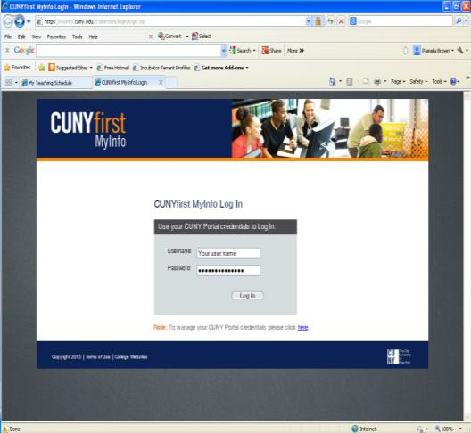
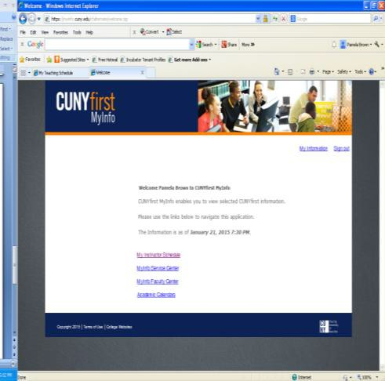
2. Select My Instructor Schedule

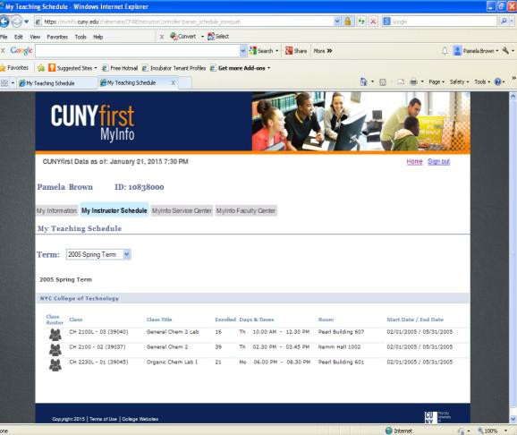
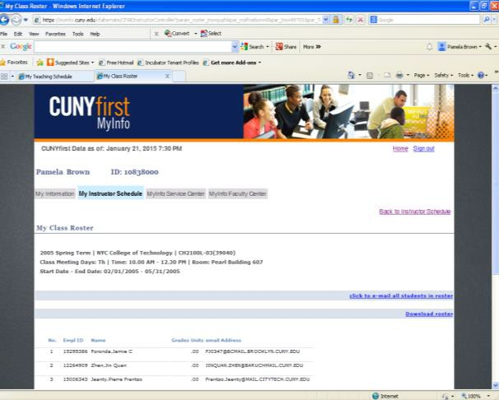
3. Select the correct Term (FALL 2017) and click on the Class Roster icon. Your roster should now appear.
4. Select Download roster

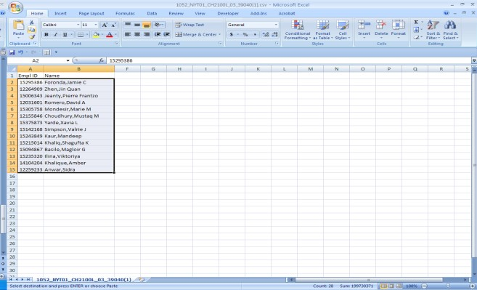
5. Copy the EMPL ID and Names of the students in your section. You may wish to make the column wider to see the entire name.
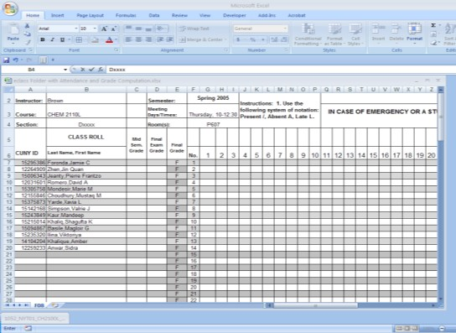
6. Open the eClass folder for this section and paste the EMPL ID and student names into the appropriate columns. You may wish to restore shading and borders. Name, save and close.

