New York City College of Technology
ePARSE

iTEC Department | Room: G-601 | Phone: (718) 254-8565
Email: itec@citytech.cuny.edu
Overview

The ePARSE system was implemented to facilitate the creation and review of a faculty PARSE report. The system is intended to help organize faculty PARSE submissions and streamline the review process. For information about the contents of the ePARSE, refer to the Guidelines for Faculty Personnel Process.

The Office of Faculty and Staff Relations (OFSR) sets due dates within the system in accordance to the Instructional Staff Calendar. The ePARSE system allows Faculty to make changes to their ePARSE on an ongoing basis. An ePARSE must be submitted via the system before the communicated due date. The submitted ePARSE is a snapshot of the PARSE information up until the point of submission. This submission will be locked for the review process on the due date. Additions or changes to the submitted ePARSE are not permitted after the due date, except as outlined in the Guidelines for Faculty Personnel Process. Note, that the submitted ePARSE can be edited and resubmitted up until the due date.

Security and Confidentiality

The ePARSE system is a web-based application intended to provide a convenient and comprehensive way for faculty members to prepare a record of their work and accomplishments in light of their overall goals. Information contained within the system is safeguarded using information security best practices. Access to the system and information therein is secured through individual credentials and role-based security. All users of the system, faculty, reviewers and members of the OFSR are subject to University information security policies.

Log into the System
Access the ePARSE system through any web browser via the URL: https://www.citytech.cuny.edu/eparse/
Log in using your City Tech Active Directory (email) credentials. (Note: Do not use @citytech.cuny.edu after your login name. Just use your email login name and your email password.)

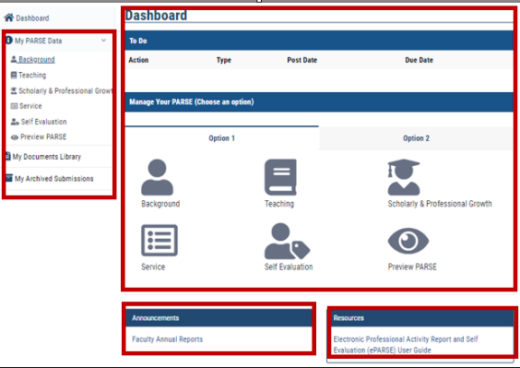
Once logged into the ePARSE system, you will be taken to the ePARSE home page, which contains a Dashboard, left navigation area, Announcements and Resources.
Dashboard section, which contains:
- To Do – shows list of pending personnel actions --i.e., annual evaluation, promotion, etc.
- Manage Your PARSE Data – shows the different categories of your ePARSE.
- Announcements section displays information related to your records.
- Resources section contains the ePARSE User Guide. Refer to the User Guide for more detailed information than contained in this handout. The User Guide also contains step-by-step instructions on all of the 5 categories.
Left navigation section contains My PARSE Data, My Documents Library and My Archived Submissions.
For information on guidelines and content, please refer to http://www.citytech.cuny.edu/ofsr/docs/guide_faculty_personnel_process.pdf.

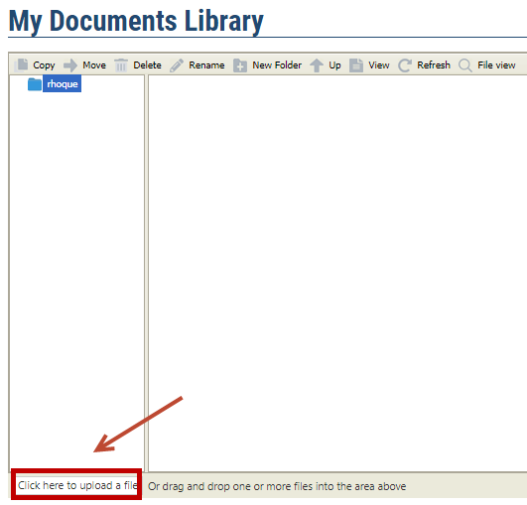
How do I upload Supporting Documents and Files?
Select My Documents Library icon on the left-hand navigation. You can drag and drop a file into the My Documents Library or Click upload file browser option.

There is a file size limit of 200 MB per file. MS Office documents and PDFs are supported, but scripting and application file types are not. Examples of supported file types are: jpg, jpeg, doc, docx, zip, gif, png, pdf, mp3, zip, xls, xlsx, ppt, pps, and pptx. Note: The following file types are NOT supported: exe, dmg, js, and html.

Note: If you rename or delete a file in My Documents Library that was previously linked to in one of the text edit fields, you must manually update links to files that you have chosen to rename or delete. If you drag and drop a folder, the file structure will not be uploaded intact; all the files will be uploaded, but will be flattened into a single collection of files. You will need to manually build the directory structures in the File Browser

How do I build my PARSE?_Option 1 – The Preferred Method

There are two options to submit your ePARSE. Option 1 is the preferred method where you will be building your ePARSE by entering information and linking supporting documents in the different fields. If you already have a PDF of your PARSE, you can use Option 2, but this process requires you to upload all supporting documents and create all of the links to your document. Therefore, it will be simpler for most faculty members to use Option 1, the preferred method. Note: If you enter information using Option 1 and also upload a PDF using Option2, Option 2 will take precedence and the reviewer will only see the PDF. The contents of the fields which you may have entered using Option 1 will NOT be visible to the reviewer.

Under Option 1 in Manage your PARSE, you will see a few different fields, such as Background, Teaching, Scholarly & Professional Growth, Service, Self Evaluation and Preview PARSE. These are the fields where you will enter your information. The Background section requires you to enter information about yourself. This tutorial will walk you through Teaching and Scholarly & Professional Growth. After you complete these sections, proceed with the other sections in the same manner. The User Guide contained in the Resources section of the ePARSE gives detailed information on each section. Refer to the Guidelines for Faculty Personnel Process for information about the contents. http://citytech.cuny.edu/ofsr/docs/guide_faculty_personnel_process.pdf

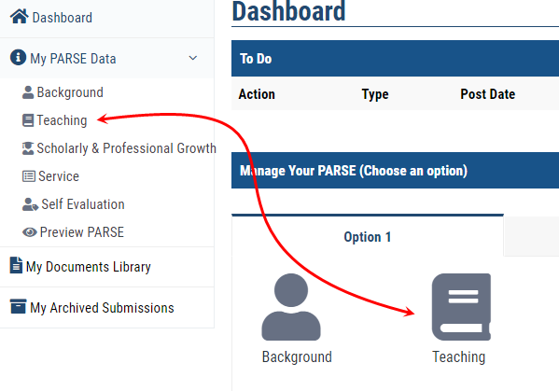
Teaching:
In this section, you can list all the courses you taught at City Tech, as well as your teaching and instructional responsibilities.
To enter your Teaching information, click the Teaching icon from Dashboard or left navigation area.

Enter your course list and teaching responsibilities. You can use the content editor to format the text.

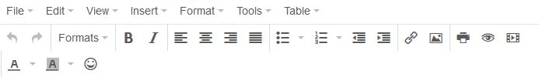

To add a web link to text you have written, select the text and right-click on the text and select Link.
You can also click on Insert -> Link in the content editor menu after selecting the text.
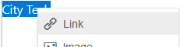

After the Insert link window is open, type in the URL and Text to display and click OK.
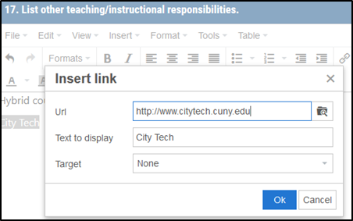

To create a link to a document, select the text and right-click on the text and select Link.
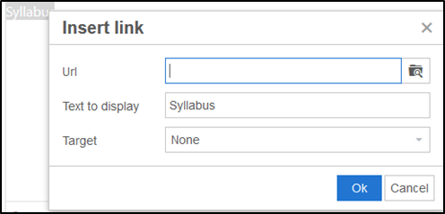
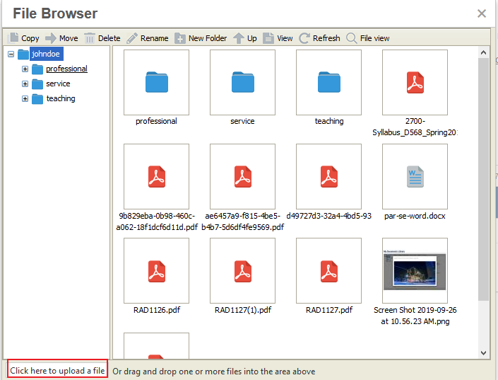
After the Insert link window is open, click on theicon to open up the File Browser.
If the file has not been uploaded in My Documents Library, there are two ways to upload a file to the My Documents Library:
- In the File Browser window, you can drag and drop your document
- Select the Click here to upload a file button on the bottom left-hand corner to locate the file on your computer to upload.

After the document has been uploaded, double-click on the file to select it in the File Browser.
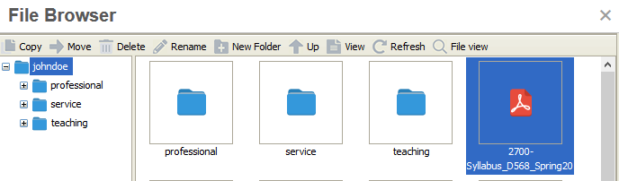
Click OK to close the Insert link box.
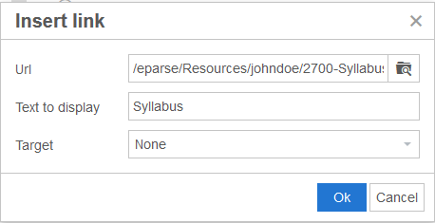

To embed an image or video directly into the text box, the files must be uploaded to the My Documents Library first. After the file has been uploaded into My Documents Library, click the icon in the content editor.
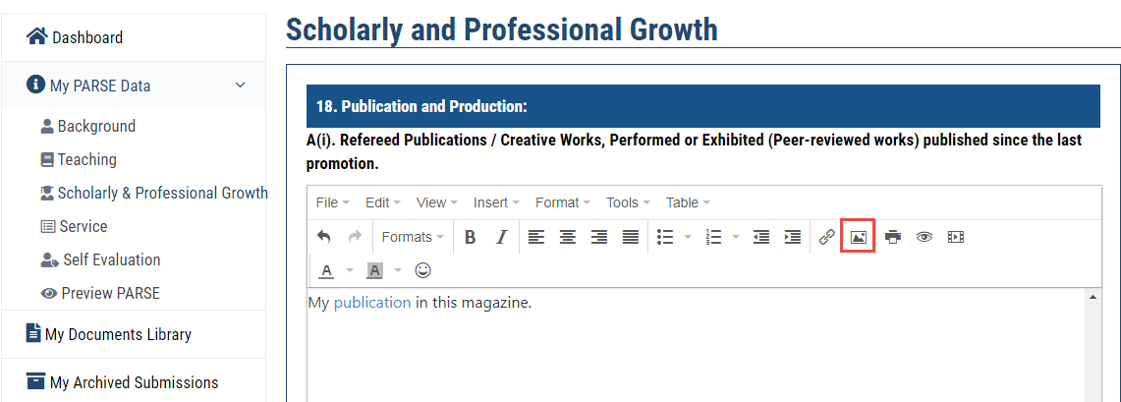
Click on the icon to select your image / video.
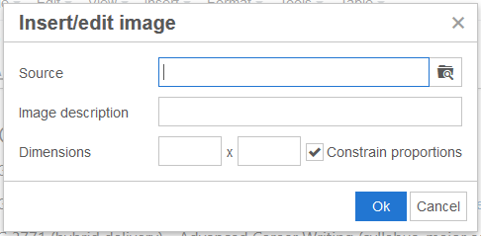
Select the Image file you want to embed from My Documents Library and enter its dimensions. It is recommended to constrain proportions.
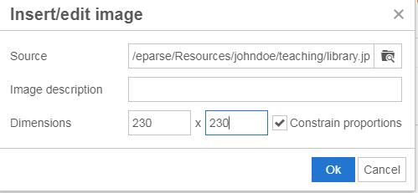

Select OK.
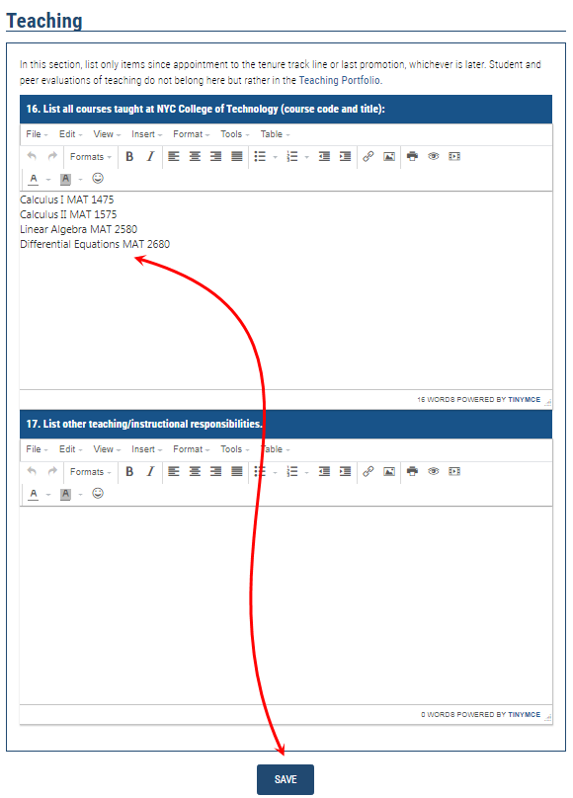
After you are done entering your Teaching information, click the SAVE button.

“Your PARSE has been updated successfully!” notice will appear."
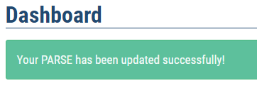

Scholarly & Professional Growth:
This section has multiple subsections. Click on the Scholarly & Professional Growth icon to enter
information in it. To add links to files and websites, see the Teaching section for instructions.
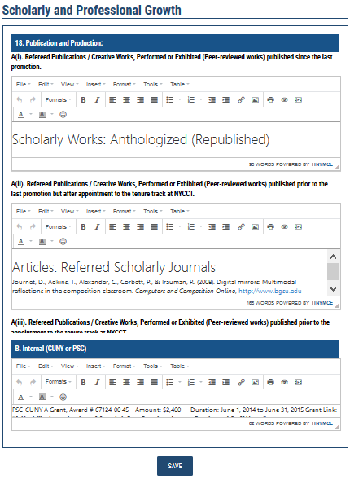
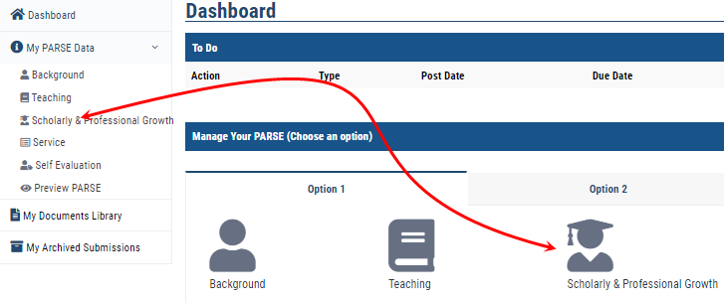

Make sure to click the Save button at bottom of the page once done entering the information.

Repeat the above steps until you have completed entering and linking all files for all sections, i.e., Service, Self Evaluation.

How can I view my PARSE?
Click the Preview PARSE icon from the Dashboard or link from the left navigation.

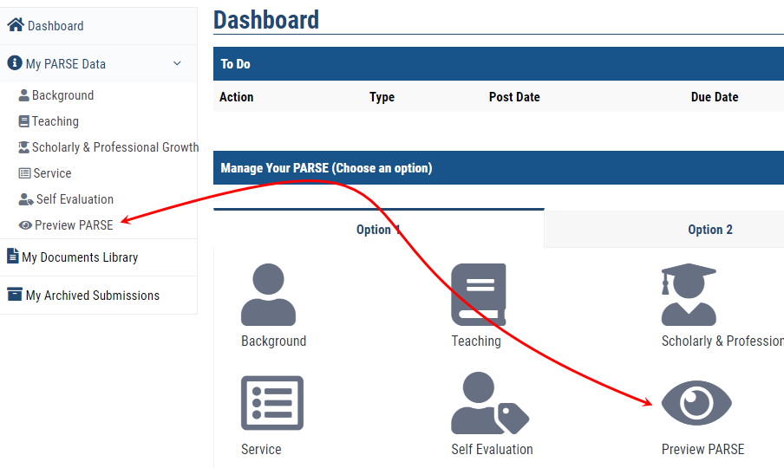

You will be able to print or save the PARSE from the Preview PARSE page. Click the PRINT PDF button at the top or bottom of the page.
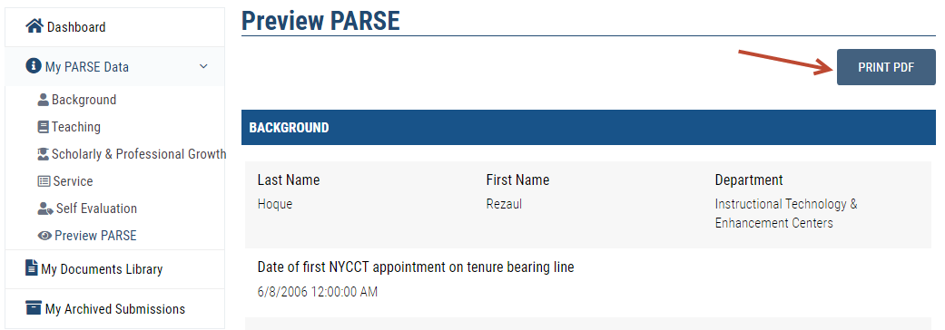
How do I submit my PARSE for review?
After you have entered in all relevant information and are ready to submit your PARSE for review, go to the Dashboard and click on an action under To Do.
You can review your PARSE by clicking on each section or the Preview button to view the entire PARSE.

Click SUBMIT FOR REVIEW on the bottom of the page to submit it.

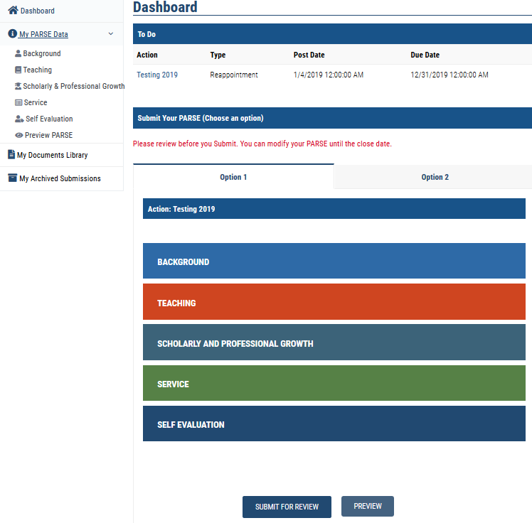

Option 2
Use this option if you already have a single document of your entire PARSE. Name your document appropriately. It is not the preferred method as you would still need to upload all relevant files into My Documents Library and link each one of them within the appropriate section of the single document (PDF).

Click an action under Action column from the Dashboard.
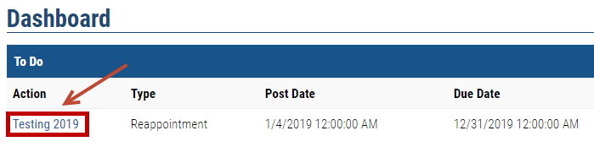

Click on the Option 2 tab.
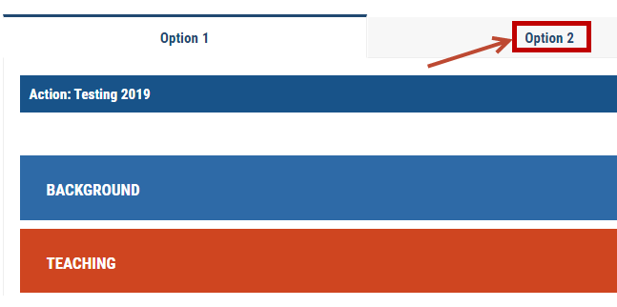

Click the Browse button.
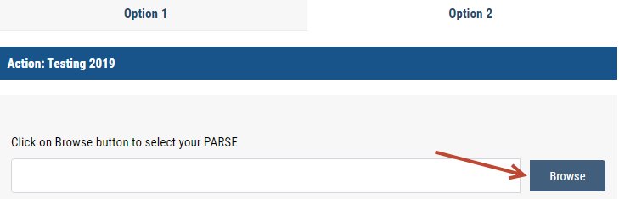

The File Browser will open, find the file and double-click on the file to select it.

If the PDF contains links to additional files, be sure to upload those files into My Documents Library (refer to “How do I upload supporting documents and files?” section.) You will then need to link to each one of those files separately in the appropriate section of your PDF. Any work you did under Option 1 will no longer be visible to the reviewers.

When finished linking all files to the PDF document, click the SUBMIT FOR REVIEW button to submit it.
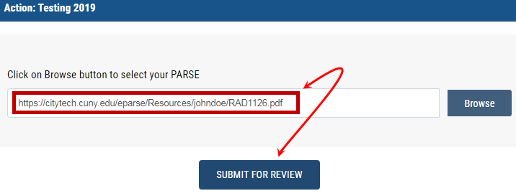

You will notice a successful submission message.
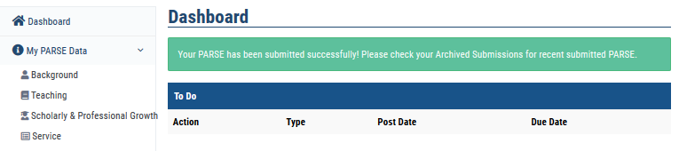

If I need to make changes after submission, how do I retract?
If the deadline has not passed for your submission, you can retract it by going to My Archived Submissions on the left navigation area.
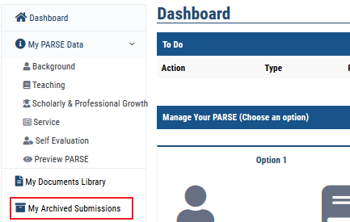

Click on next to your submission to retract it.
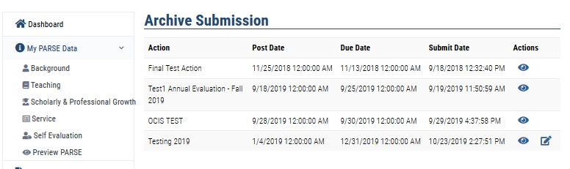

Click the Continue button to retract.
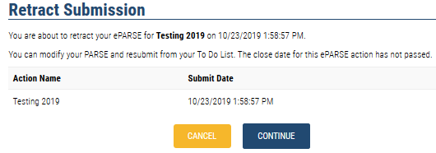

Refer to the User Guide under Resources on the ePARSE system for more detailed information and each of the other categories.

